ASES Foundation Individual Donation Form
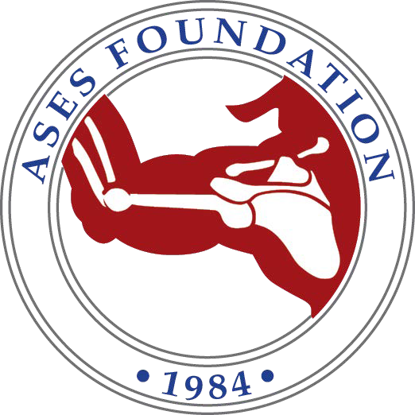

Thank you for making a contribution to the ASES Foundation, your support is truly appreciated. Your tax deductible gift will help us expand the research and education programs that are vital to the subspecialty of shoulder and elbow surgery.

Contribution Levels:
- $ Pioneer Circle .........................$50,000 and above
- $ Founder Circle ........................$25,000 – $49,999
- $ President Circle ......................$15,000 – $24,999
- $ Chairman Circle .....................$5,000 – $14,999
- $ Benefactor Circle ....................$1,000 – $4,999
- $ Supporter Circle .....................$250 – $999
- $ Friend of ASES Circle ...........Up to $249

I will pay my total donation of $
- As a multi-year pledge to be paid in:

- In full this year
- 2 years (Amount per year: )
- 3 years (Amount per year: )

*Contact the ASES Foundation Office for other pledge options. Donations made to ASES are tax deductible to the extent permitted by law.

Name:

Address:

City: State: Zip Code:

Phone: E-mail:

- Check Enclosed (Please make checks payable to: ASES Foundation)
- MasterCard ❑ Visa ❑ AMEX ❑ Cash

Cardholder Name:

Card Number: Exp:

Signature:

For any questions, please contact the ASES Foundation at:
9400 W. Higgins Road, Suite 500, Rosemont, Illinois 60018-4976
Phone: (847) 698-1629 • Fax: (847) 268-9499
Email: ases@aaos.org

